**SPOORTHI B**

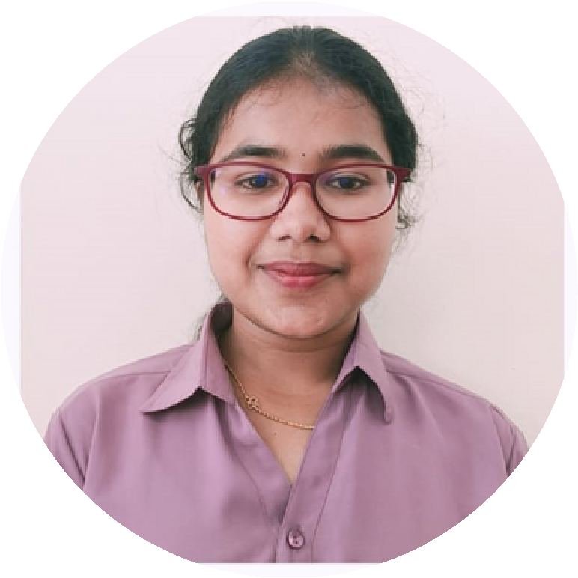

**PROFILE**

I

am

a

dynamic

learner

with

good

analytical

and

interpersonal

skills,

and

I am

looking

forward

to

start

my

career

as

an

entry-level professional in

IT sectors.

**CONTACT ME**

+91 9482906943

[shettyspoorthib@gmail.com](mailto:shettyspoorthib@gmail.com)

D/o Babu Rajendra

shetty

Old hospital road,

near PLD bank,

Shikaripura.

Shivamogga. 577 427

*Student*



# EDUCATION

Nitte Meenakshi Institute of Technology,

Bengaluru pursuing MCA (2022-still)

Kumadvathi First Grade College, Shikaripura, Shivamogga.

Bachelor of Science. 78.90 (2018-2021)

Kumadvathi Science And Commerce PU College, Shikaripura, Shivamogga. 81.33 (2017 - 2018)

Kumadvathi High School, Shikaripura ,

Shivamogga. 86.56 (2016-17)

# LANGUAGES KNOWN

Kannada



English

Hindi

## Tulu

## SKILLS

HTML, CSS & javascript

C Programming

Java

Python

DBMS using SQL

Unix

C# with .NET

**INTERESTED IN**

DevOps

Software testing

RPA

## PROJECTS AND CERTIFICATIONS

Project on virtual Phone using Python.

Data science Project For the Predection of laptop price.

Wifi Controlled and Obstacle Avoidance Rover

(mini group project).

AI ML using Python certificate by Aqmenz Automation PVt Ltd.